* CERTIFICATE OF COMPLIANCE *
 | Date: |  | 14 May 2026
 | Manufacturer: |  | Bconduct HK
 | Customer:
 | PO Number:

It is hereby certified that the parts and / or material included in this shipment been manufactured and /or processed in conformance to the customer’s manufacturing drawings, materials, and specifications.

The specific conformances as per the notes of the drawing are:
# | Part No | Description | REV | QTY

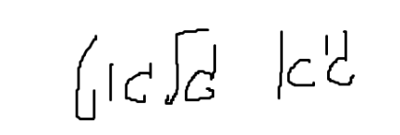



Certified by: ________

Bconduct HK




